**Experiment 1: Measuring the characteristic diagram of**

**non-linear components**

a) Measure the resistance of the cold light bulb and document both the measured value and

the measurement device being used.

**Measured Device.**  Metrahit/TRMS Advanced

Rlight bulb=22.73 Ω.

b) Measure the voltage across the light bulb and the current flowing through it within the

range 0.1 V to 10 V. List the data in a table and consider that each decade should have at

least 3 measurement points. Use the adjustable power supply to adjust the voltage.

|  |  |  |
| --- | --- | --- |
| U0/V | U/V | I/mA |
| 0.1 | 0.0337 | 1.504 |
| 0.2 | 0.0672 | 2.966 |
| 0.5 | 0.1739 | 6.8 |
| 1 | 0.4906 | 12.1 |
| 2 | 1.431 | 18.7 |
| 5 | 4.378 | 33.2 |
| 10 | 9.332 | 51.1 |

c) Plot the characteristic function I = f(U) using lin-lin scaling, and graphically determine both

the DC resistance R and the incremental resistance r at the operating points U = 0.1 V,

1.0 V and 10.0 V. Enter the results into the following table.

|  |  |  |  |
| --- | --- | --- | --- |
| U/V | I/mA | R/Ω | r/ Ω |
| 0.1 | 3.935 | 27.45 | 30.00 |
| 1 | 15.16 | 65.63 | 159.52 |
| 10 | 52.83 | 187.96 | 280.72 |

d) Plot the I = f(U) diagram using log-log scaling.

e) Within the voltage range 0.5V < U < 10V, the characteristic function is to be approximated

by the expression in Equation 1. Present the pre-calculated values in a log-log diagram.

C:\Users\Hasan\Desktop\Безымянный.png

|  |  |
| --- | --- |
| U/V | I/mA |
| 0.1 | 4.239 |
| 0.2 | 6.164 |
| 0.5 | 10.1102 |
| 1 | 14.7 |
| 2 | 21.373 |
| 5 | 35.056 |
| 10 | 50.9703 |

f) Use a regression line (‘best linear fit’) to approximate the measured data in the log-log

diagram within the range 0.5V < U < 10V.

g) Graphically determine the parameters a and b in Equation 1 from the regression line.

h) Prove the results obtained in g) by superimposing the graph of the calculated values on

both the linear and the logarithmic diagram.

Log-Log plot.

Orange line is represents calculated values, blue line: measured values.

Orange line is represents calculated values, blue line: measured values.

**Experiment 2:**

**Equipment:**

**Multimeter Metrahit TRMS ADVANCE**

**UniCTor A43**

a) We set up a circuit like the picture below:

The potentionmeter

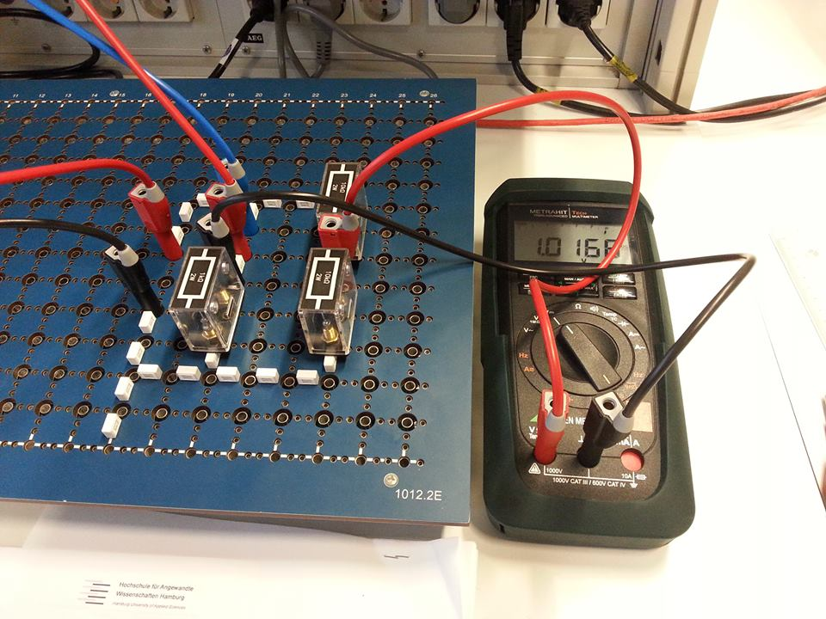

Power supply

Uo = 6V

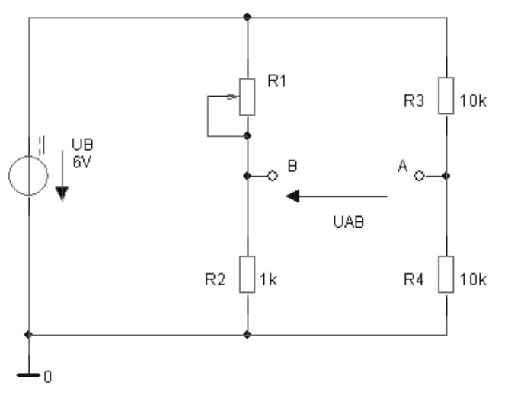

b) The bridge is balanced => $\frac{R4}{R3}= \frac{R2}{R1}$ => R1 = R3 $\frac{R2}{R4}$ = 1000 Ω

c) and d)

|  |  |  |  |
| --- | --- | --- | --- |
| **R1 Ω** | **UAB (V) Calculated** | **UAB (V) Measured** | **r** |
| 550 | -0,8710 | -0,8589 | -0,45 |
| 750 | -0,4286 | -0,4143 | -0,25 |
| 1000 | 0,0000 | 0,0157 | 0 |
| 1250 | 0,3333 | 0,3498 | 0,25 |
| 1400 | 0,5000 | 0,5167 | 0,4 |
| 1700 | 0,7778 | 0,7946 | 0,7 |
| 2000 | 1,0000 | 1,0168 | 1 |

e. UAB = f(R1)

UAB (V)

f) E0 = = = 1.5 * 10-3